|  |  |
| --- | --- |
| **NAME:** | Bodhisatya Ghosh |
| **UID:** | 2021700026 |
| **BRANCH:** | T.Y. CSE Data Science |
| **BATCH:** | B |
| **SUBJECT:** | FOSIP |
| **EXP. NO.:** | 9 |

**AIM: -** To study image processing Morphological Operation

# OBJECTIVES:

1. Image Processing using Morphological Operation
2. Download the Conference paper from IEEE Xplorer published after 2018
3. Develop the algorithm and process the following images for different types of images
4. Give your conclusion based on results obtained.

# INTRODUCTION:

Morphological image processing is a set of operations that process images based on their shape and structure. These operations are rooted in mathematical morphology, which is a branch of mathematical set theory and topology. Morphological operations are particularly useful in image analysis and computer vision for tasks such as noise reduction, object detection, and image enhancement.

The two fundamental morphological operations are erosion and dilation. These operations are applied to a binary or grayscale image using a structuring element, which defines the neighborhood around each pixel.

## Erosion:

Erosion is a morphological operation that shrinks the boundaries of objects in an image.

The basic idea is to move the structuring element through the image, and for each pixel, if all the pixels under the structuring element are true (or have high intensity), then the pixel remains true; otherwise, it is eroded (set to false or low intensity).

## Dilation:

Dilation is the opposite of erosion. It expands the boundaries of objects in an image.

If at least one pixel under the structuring element is true, the pixel in the output image becomes true (or takes on a higher intensity).

## Opening:

Opening is a combination of erosion followed by dilation.

It is useful for removing noise and small objects while preserving the shape and size of larger objects.

## Closing:

Closing is a combination of dilation followed by erosion.

It is effective in closing small holes and gaps in objects.

## Hit-or-Miss Transformation:

This operation is used for pattern matching. It identifies locations in an image where a given pattern (defined by two structuring elements) fits exactly.

## Morphological Gradient:

The morphological gradient is the difference between the dilation and erosion of an image. It highlights the boundaries of objects.

In morphological image processing, the choice of the structuring element and its size is critical and depends on the specific characteristics of the objects in the image. Structuring elements can be simple shapes like squares or circles, or more complex shapes depending on the desired operation.

## Morphological operations are commonly used in various applications, including:

* **Noise Reduction:** Erosion can help remove small noise, while dilation can close gaps.
* **Segmentation:** Opening and closing operations can be used to separate or connect regions of interest.
* **Object Detection:** Morphological operations can be applied to enhance features and make object boundaries more distinct.

Libraries like OpenCV in Python provide efficient implementations of morphological operations, making it easy to apply these techniques to images in real-world applications.

# EXPERIMENTATION:

**CODE:**

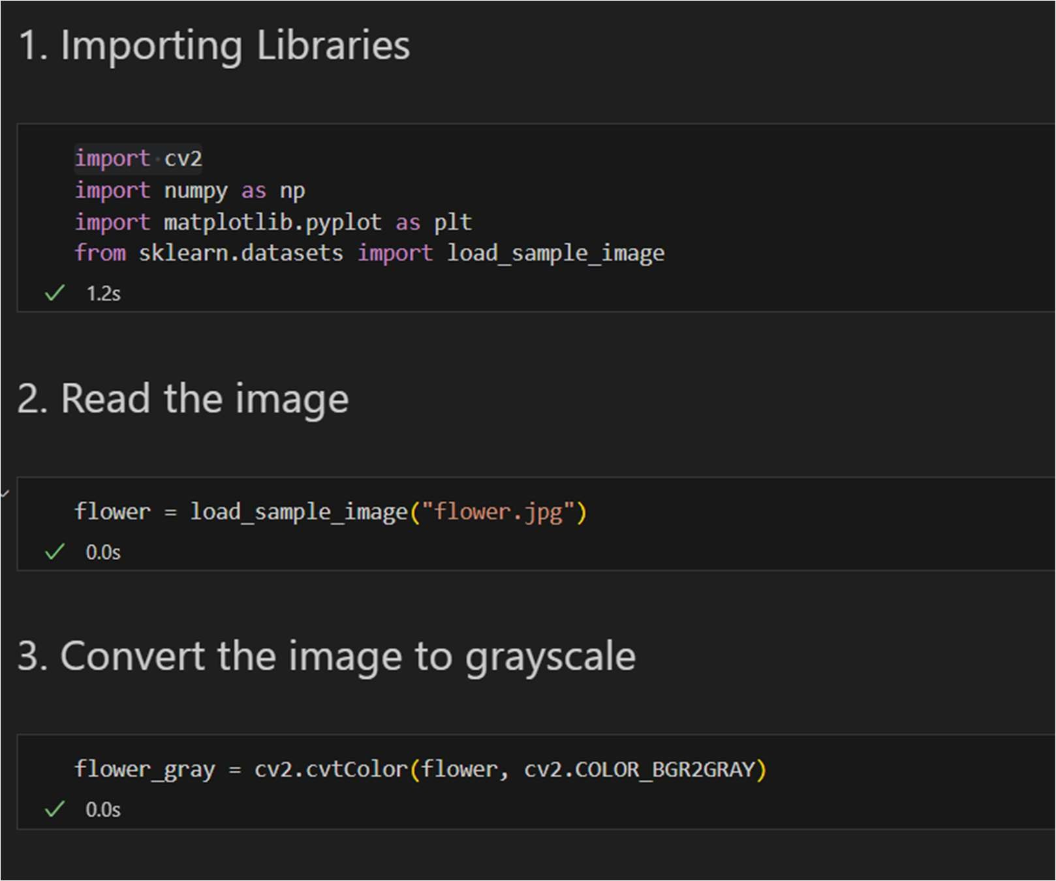

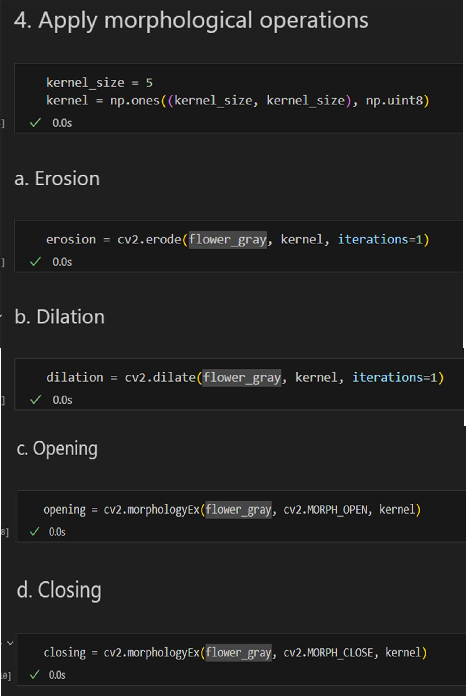

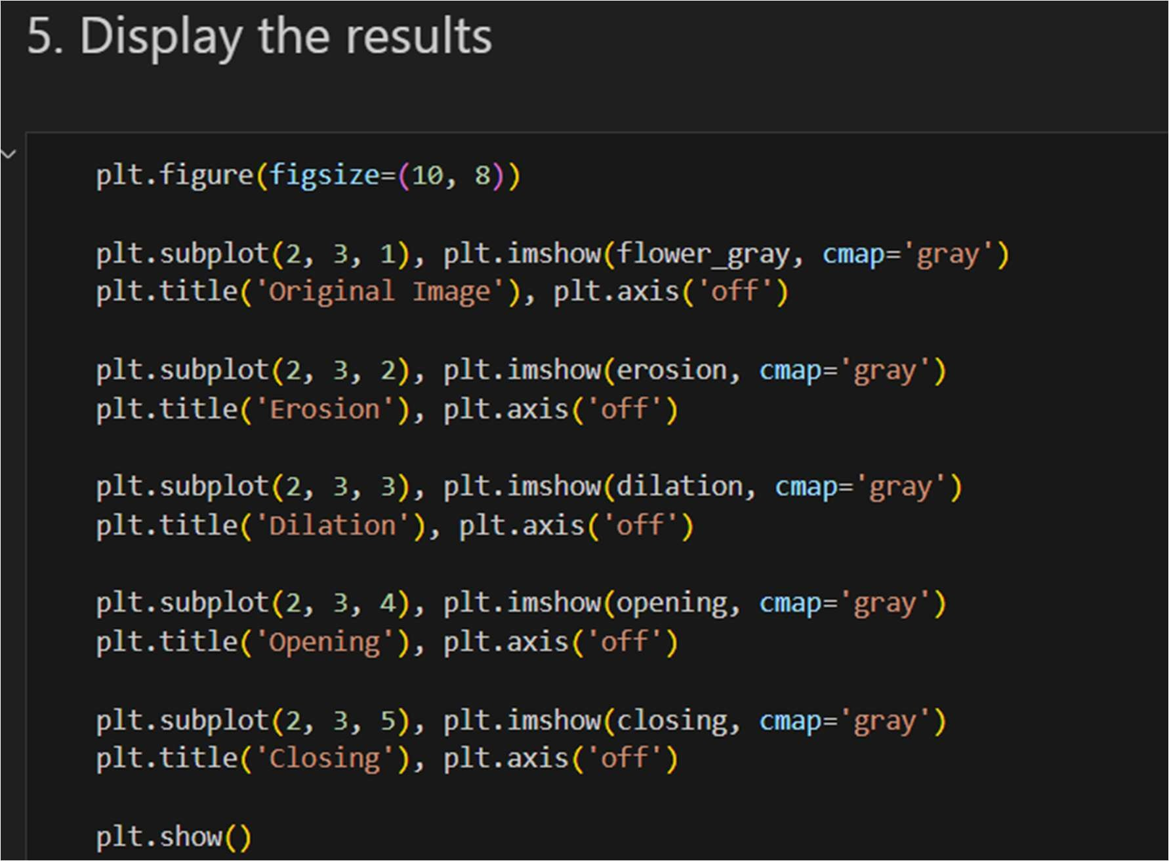

# RESULT:

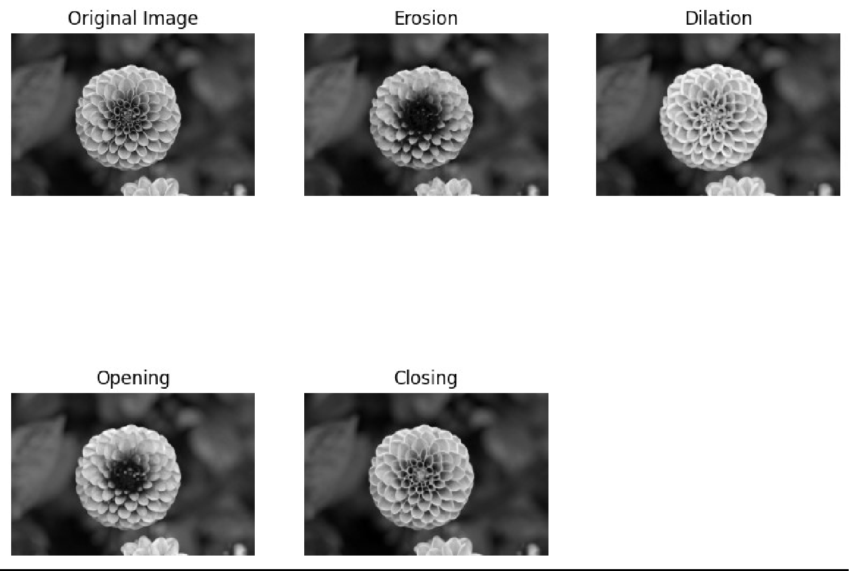

**CONCLUSION:**

I learned the implementation and application of morphological image processing using open CV library in python.

# REFERENCES:

1. https://[www.geeksforgeeks.org/matlab-erosion-of-an-image/](http://www.geeksforgeeks.org/matlab-erosion-of-an-image/)